Practice Questions

Q1: Write the set 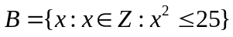 in tabular form, where Ζ is the set of integers.

Q2: List the elements of set A , where A = Set of any three irrational numbers.

Q3: List the elements of the following set, where Z is the set of integers
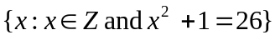

Q4: Write the set A={8,9,10,11,12,13,14,15} in set builder form.

Q5: Write all proper subsets of 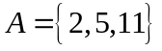.

Q6: Let A = { x ∈ Ζ⁺ | x is divisible by 2 but less than 30 } and B = { y ∈ Ζ⁺ | y is divisible by 3 but less than 20 } then prove that A ∩ B = B ∩ A .

Q7: Find x and y ,where (x +2 y, 3x) = (3, 12).

Q8: For the relation matrix. 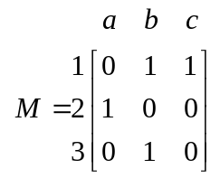 List the set of ordered pairs represented by M.

Q9: Let 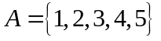Determine the relation R such that xRy iff 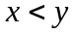. Also find the domain and range of the relation.

Q10: Find the relation R of the given directed graph.

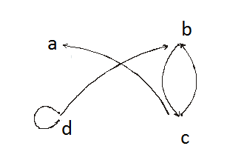
Q11: Let R be the relation on the set of integers Z defined as

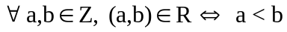 Is R reflexive?

Q12: Use a Venn diagram to represent the following: 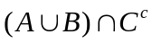 when A , B and C are overlapping.

Q13: Let 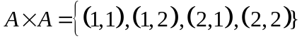 Determine the relation
such that 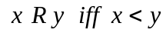

Q14: Let 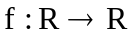defined as 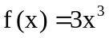 . Show that the given function is well defined.

Q15: Let 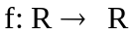be defined by f(x) = 4x – 7. Show that f is one-to-one function.

